Spalding Community Services District
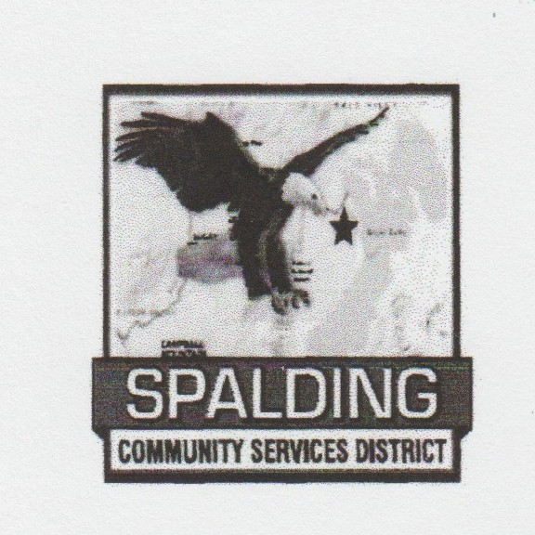  Eagle Lake Community Center  502-907 Mahogany Way  Susanville, CA 96130 | Directors:  Ellen Stallings  Scott Hagen | Staff:  Mike Garcia: General Manager

Meeting ID: 899 0713 8639
Passcode: 502907
Link:
https://us06web.zoom.us/j/89907138639?pwd=LlQmZoNnav2CvfHxFJtCo48ZRJ9SSy.1

Phone Call In: (646) 568-7788
Meeting ID: 899 0713 8639#
Passcode: 502907#

Standing Budget Committee Meeting
NOTICE OF CANCELLATION

Budget Committee Meeting
(The 1st Tuesday of the Month)
4:00 PM
July 7, 2026

Notice is hereby given that the regularly scheduled Budget Committee Meetings of the Spalding Community Services District scheduled for Tuesday, July 7, 2026, have been canceled.

Regular committee meetings will resume at their next regularly scheduled meeting unless otherwise noticed.

7/2/26

